Remo Instructions

This document provides an overview of to use the Remo platform, this document contains:
- What is Remo?
- How to Join
- Navigating Remo

What is Remo?
Remo is a virtual conference platform that aims to make the remote world feel natural and humanized. If you have a moment, here are some quick resources that provide an overview of the platform.
- PDF guide from Remo
- YouTube Video from Remo
- YouTube video from a third party, but more in-depth

How to Join:
First, make sure your device is compatible – currently, Remo does not have an iOS or Android app, so you will need to join from a computer. Google Chrome is the preferred browser, though most major browsers will work as well. It also does not have a dial-in function, so it is important your audio works. Go to geartest.remo.co to test your device compatibility and audio/video. Note: you are using a university or employer's VPN, firewalls may not be detected. Try accessing Remo through your personal Internet connection.
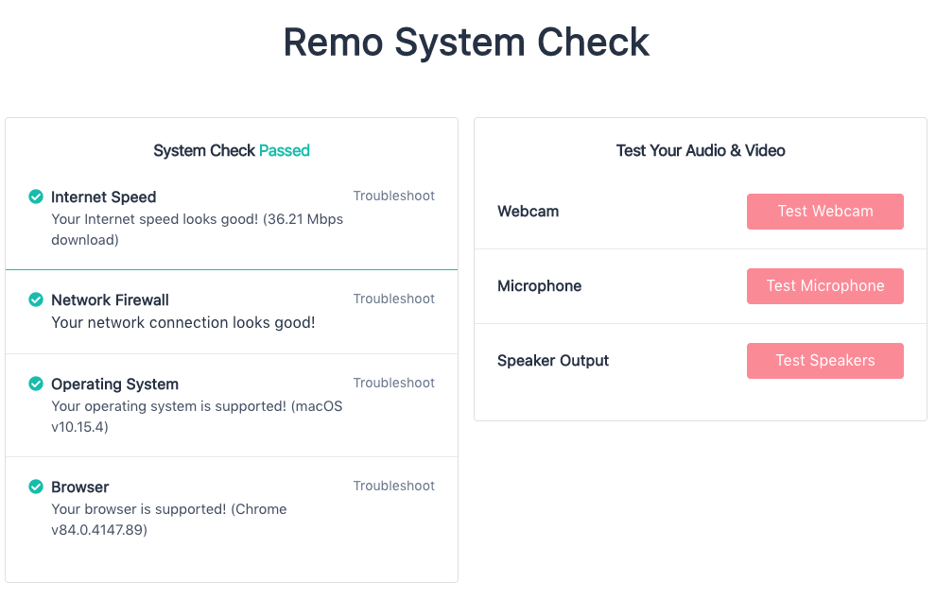

The Remo link will take to a landing page for the event. Until the event has begun, you will see a countdown timer on this landing page. Once the event has begun, you will be able to join by clicking the green button that says “Join event now!”

Navigating Remo
When you enter the event, at first you’ll see a pop-up welcome message. We encourage using headphones with a built-in microphone if available.

After you dismiss the welcome message, you will be brought into the conference room. When you enter Remo, you will be randomly placed at a table. Remo is a visual top-down view, 2-D map comprised of interactive conference rooms on different floors. The app uses video, audio and chat to allow people within the space to interact naturally in real-time, from anywhere in the world.

It will look similar to this:
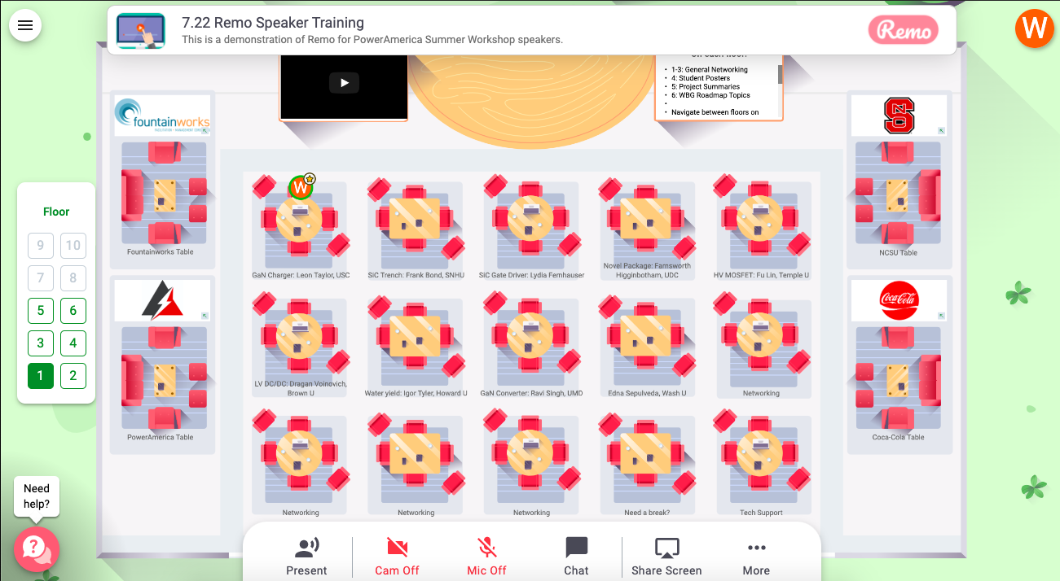

First, we encourage you to add your “Virtual Business Card.” In the top left corner, click the your initial icon, then “My Profile”:

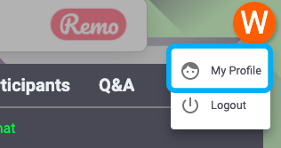

Your virtual business card will appear. Click “Edit Profile.” You can add your job title/company, company website, your LinkedIn, and a scheduling app such as Calend.ly for appointments.

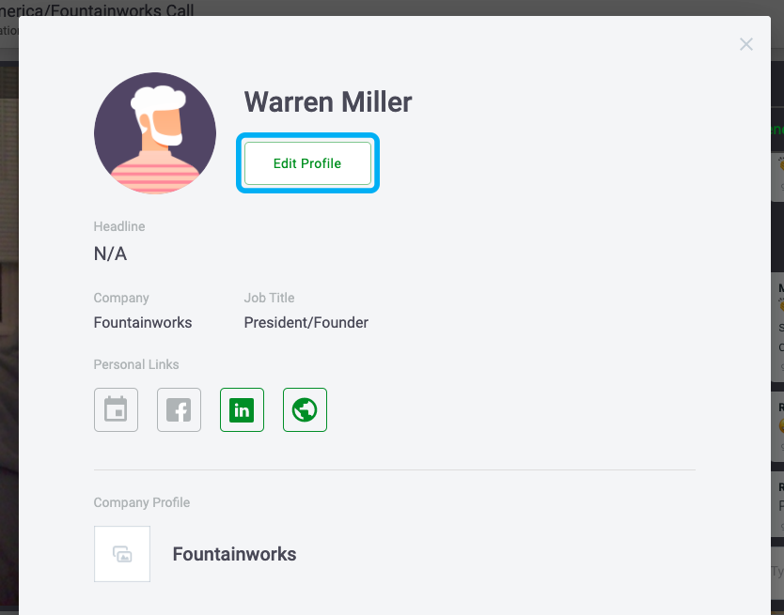

Enter your information, then make sure you “Save Changes.”
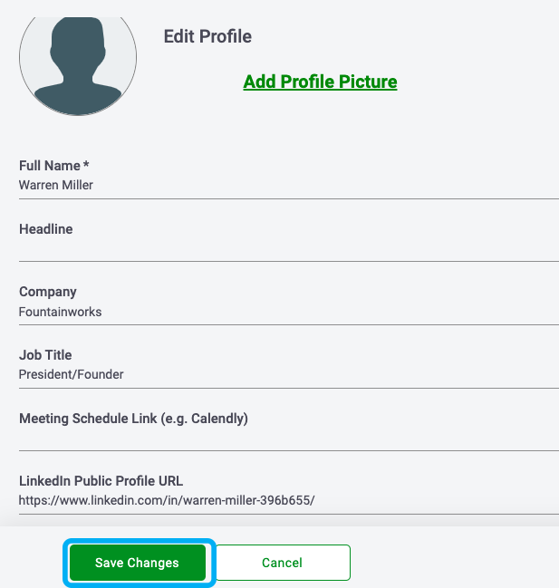

In Networking Mode, you will can change tables by double-clicking on the table you’d like to sit at.

You are able to interact with everyone at your table with video and audio, and also share screens. Only those at your table can see it. Each person’s webcam video will appear at the top of your screen:
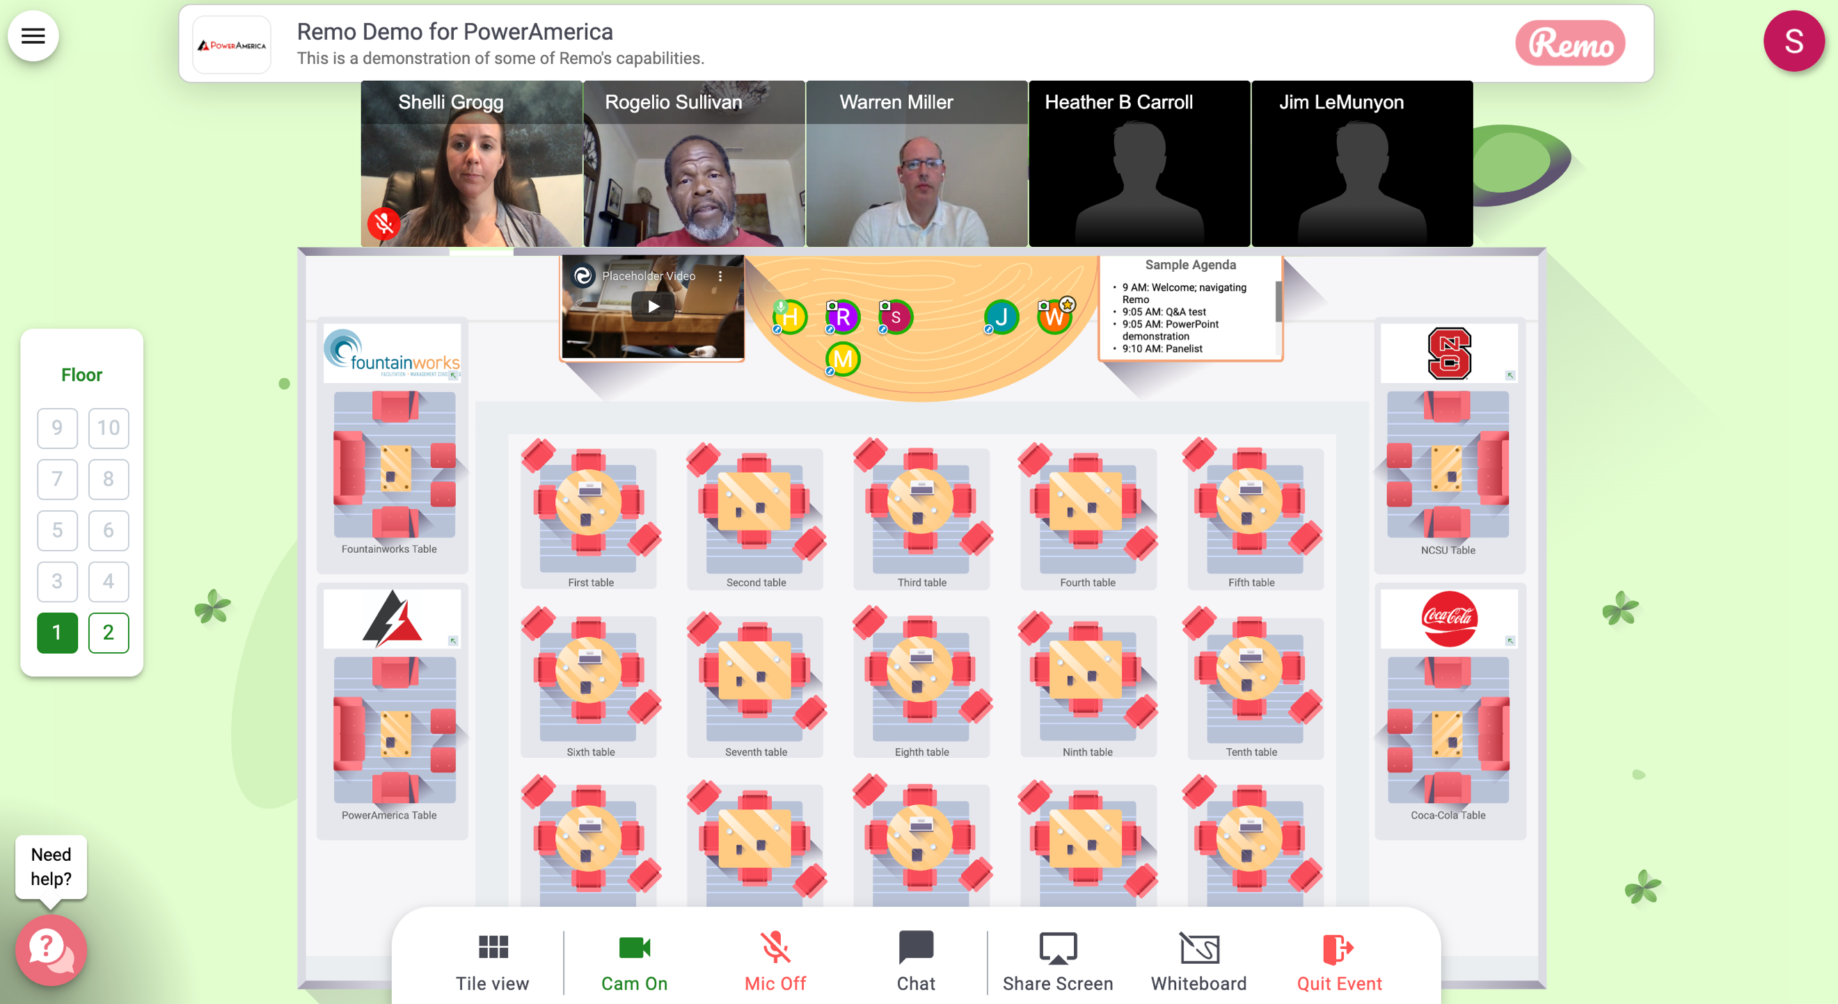

If you want to sit with someone in particular, click the Chat button and search for them. Then, you can send a private message to see which floor they are on or which table they are sitting at. We will have two floors open to accommodate for all registered participants, and depending on when you enter, you may be placed on either floor. You can navigate between floors while in Networking Mode by using the side “Elevator” buttons to the left of the conference floor:

That’s it! If you have questions, you can join the Technical Support table or chat anyone named “Tech Support.”

